2025 Eastern Washington Regional History Day Contest
Submission Instructions: Websites
The submission deadline for websites is:
Tuesday, February 18, 2025 at 8:00 p.m.
https://wa-ewrc.nhd.org/

Submitting Websites
- Please be sure your History Day project follows all of the general contest rules found in the new Contest Rule Book, as well as the website category rules on pages 33-36.
  - Remember that your website’s home page serves as your title page (see page 34, Rule E4) and that your process paper and annotated bibliography must be included in PDF format as an integrated part of your website (see page 35, Rule E7).
- To submit your entry, please visit your contest webpage and log in to your student account.
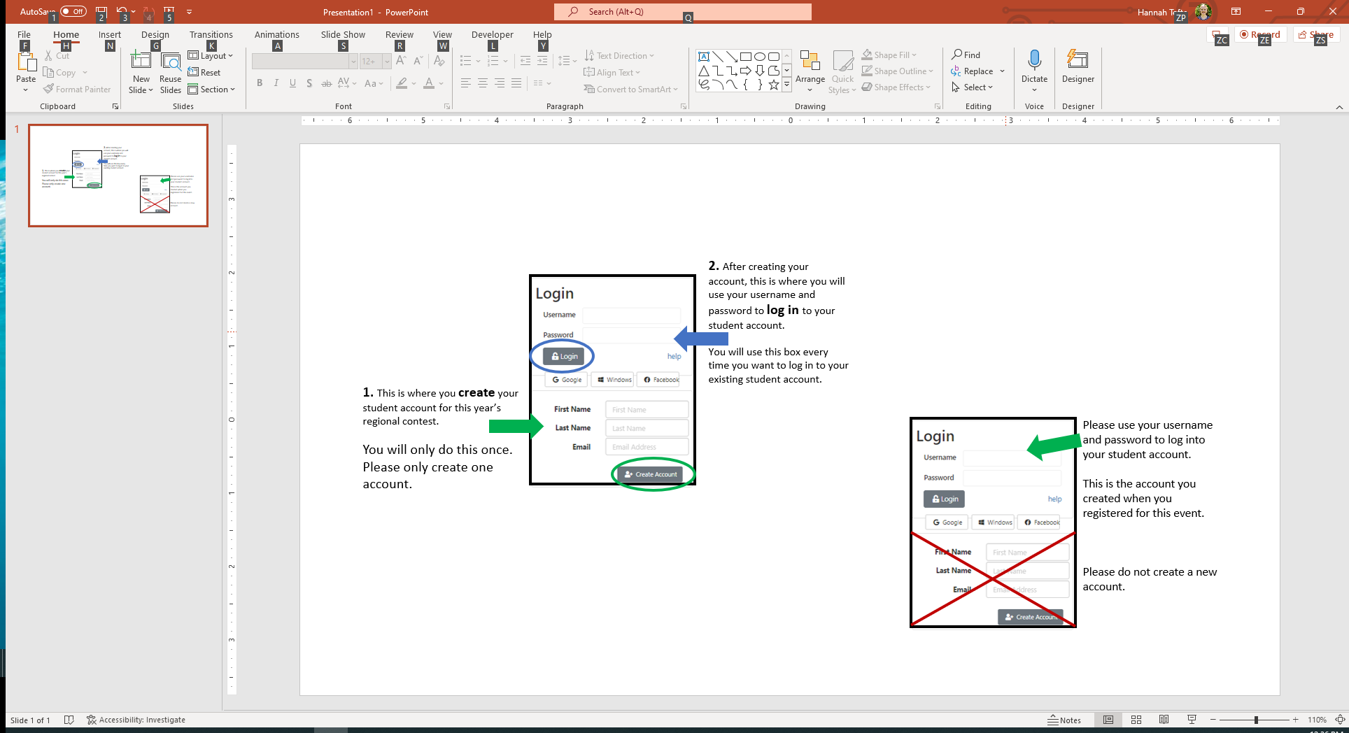
  - If you have forgotten your username and password, try the “help” button to recover them However, this help feature will not work with some student email accounts. You may also contact Hannah Tofte hannah.tofte@k12.wa.us for login help.
- Once logged in, click your name in the top right corner of the screen and select My Profile.
  - On the top left side of the screen, click the Entry tab.
  - Enter your eight-digit NHDWebCentral site key into the NHDWebCentral Site Key box.
  - You may also enter a link to your website in the Link box.

